# Using Right Triangles to Evaluate Trigonometric Functions

In trigonometry, we often place triangles on the coordinate plane. The figure below shows a right triangle with a vertical side of length $y$ and a horizontal side of length $x$. Notice that the triangle is inscribed in a circle of radius $1$. Such a circle, with a center at the origin and a radius of $1$, is known as the unit circle.

We can define the trigonometric function in terms of an angle $t$ and the lengths of the sides of the triangle. The adjacent side is the side closest to the angle, $x$. The opposite side is the side across from the angle, $y$. The hypotenuse is the side of the triangle opposite the right angle, $1$.

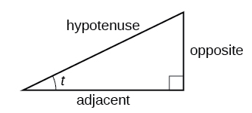

Given a right triangle with an acute angle of $t$, the first three trigonometric functions are:

Sine $\sin{t}=\frac{\text{opposite }}{\text{hypotenuse}}$ $\sin{t}=\frac{y }{1}$

Cosine $\cos{t}=\frac{\text{adjacent }}{\text{hypotenuse}}$ $\cos{t}=\frac{x }{1}$

Tangent $\tan{t}=\frac{\text{opposite} }{\text{adjacent}}$ $\tan{t}=\frac{y }{x}$

Examples: Find the indicated value of each triangle below.

1. Find the value of $\sin{α,}\cos{α}$, and $\tan{α}$.

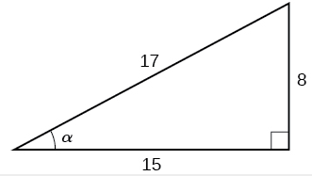

1. Find the lengths of the missing sides given: $\tan{A}=\frac{5}{12}, b=6$

## Reciprocal Functions

In addition to sine, cosine, and tangent, there are three more functions. These too are defined in terms of the sides of the triangle.

Secant $\sec{t}=\frac{\text{hypotenuse} }{\text{adjacent}}$

Cosecant $\csc{t}=\frac{\text{hypotenuse} }{\text{opposite}}$

Cotangent $\cot{t}=\frac{\text{adjacent} }{\text{opposite}}$

You may notice these functions are the reciprocals of the first three functions.

$\sin{t}=\frac{1}{\csc{t}}$ $\csc{t}=\frac{1}{\sin{t}}$

$\cos{t}=\frac{1}{\sec{t}}$ $\sec{t}=\frac{1}{\cos{t}}$

$\tan{t}=\frac{1}{\cot{t}}$ $\cot{t}=\frac{1}{\tan{t}}$

Examples: For each triangle below, find the value of all six trigonometric functions for the given angle.

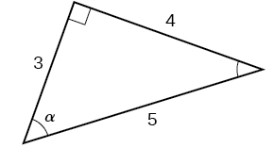

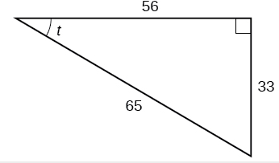

## Finding Trigonometric Functions of Special Angles Using Side Lengths

It is helpful to evaluate the trigonometric functions as they relate to the special angles – multiples of $30°, 60°,$ and $45°$. Remember, however, that when dealing with right triangles, we are limited to angles between $0°$ and $90°$.

Suppose we have a $30°, 60°,$ $90°$ triangle, which can also be described as a $\frac{π}{6},\frac{π}{3},\frac{π}{2}$ triangle. The sides have lengths in the relation $s, \sqrt{3s}, 2s$. The sides of a $45°, 45°,$ $90°$ triangle, which can also be described as a $\frac{π}{4},\frac{π}{4},\frac{π}{2}$ triangle, have lengths in the relation $s,s,\sqrt{2s}$.

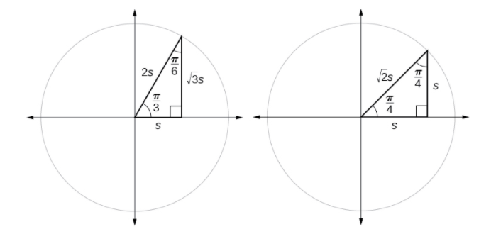

Examples:

1. Find the exact value of the trigonometric functions of $\frac{π}{3}$, using side lengths.
2. Find the exact value of the trigonometric functions of $\frac{π}{4}$, using side lengths.

# Using Trigonometric Functions

In previous examples, we evaluated the sine and cosine in triangles where we knew all three sides. But the real power or right-triangle trigonometry emerges when we look at triangles in which we know an angle but do not know all the sides.

Examples:

1. Find the unknown sides of the triangle.

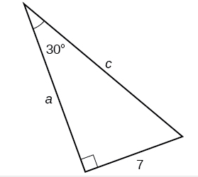

1. A right triangle has one angle of $\frac{π}{3}$ and a hypotenuse of 20. Find the unknown sides and angle of the triangle.
2. Find $x$.

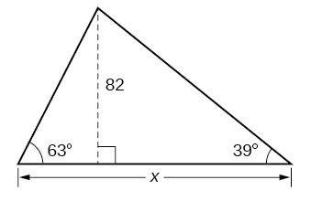

# Using Right Triangle Trigonometry to Solve Applied Problems

Right-triangle trigonometry has many practical applications. Before we can begin looking at some examples, it is important to know the vocabulary.

The **angle of elevation** of an object above an observer relative to the observer is the angle between the horizontal and the line from the object to the observer’s eye. The **angle of depression** of an object below an observer relative to the observer is the angle between the horizontal and the line from the object to the observer’s eye.

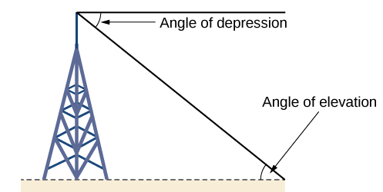

When solving application problems, there are some general guidelines that can help you solve:

1. Make a sketch of the problem situation.

2. Identify the known and unknown information and use that information to label your sketch.

3. Write an equation relating the unknown and known quantities.

4. Solve the equation for the unknown.

Examples:

1. A 200-foot tall monument is located in the distance. From a window in a building, a person determines that the angle of elevation to the top of the monument is $15°$ , and that the angle of depression to the bottom of the monument is $2°$ . How far is the person from the monument?
2. There is an antenna on the top of a building. From a location 300 feet from the base of the building, the angle of elevation to the top of the building is measured to be $40°$ . From the same location, the angle of elevation to the top of the antenna is measured to be $43°$ . Find the height of the antenna.
3. A 23-ft ladder leans against a building so that the angle between the ground and the ladder is $80°$ . How high does the ladder reach up the side of the building?